Living on OW/ODSP and turning 65?

When you turn 65, you might no longer qualify financially for Ontario Works (OW) or Ontario Disability Support Program (ODSP). This is because seniors’ benefits like Old Age Security (OAS), Guaranteed Income Supplement (GIS) and/or Canada Pension Plan - Retirement (CPP) often pay more than OW/ODSP.
Getting these seniors benefits often means that your income will be too high to qualify for OW/ODSP.
Be prepared for some changes to your income and benefits when turning 65:
- Social assistance will ask you to apply for seniors’ benefits and your income will probably increase
- Your drug coverage is no longer linked to OW/ODSP
- Subsidized housing (also called RGI) rent may increase a lot with higher income
- Your pharmacy may ask you to pay a $100 fee each year plus $6.11 for each prescription before you can get your medication
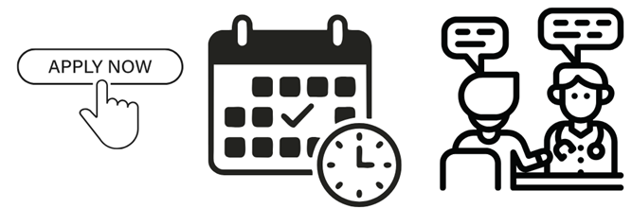
Don’t panic! There are things you can do to make your transition between OW/ODSP and seniors’ benefits easier.
Top 5 Tips on Protecting your Income When Turning 65
☐ File your taxes on time every year
☐ Apply for seniors’ benefits up to 11 months before you turn 65
☐ Tell OW/ODSP about any seniors’ benefits you get right away
☐ Apply for a fee waiver for the seniors drug program before you turn 65
☐ Use your social assistance health benefits before you turn 65 and apply to keep them

- File your taxes every year
Some seniors’ benefits use your tax returns to decide if you are eligible, so you and your spouse (if you have one) should file your tax returns by April 30 each year even if you have no income to report. Filing taxes also means you can claim the Canada Groceries and Essentials Benefit (formerly the GST/HST credit) rebate and other tax credits, access prescription drugs without paying a fee, and apply for the Canadian Dental Care Plan.
You may be eligible to get help with filing your taxes at a free tax clinic – visit this Government of Canada website to learn more.
- Apply for seniors’ benefits up to 11 months before you turn 65
Apply for Old Age Security and the Canada Pension Plan - Retirement (if eligible) up to 11 months before you turn 65.
Many people are automatically enrolled into OAS, but not everyone. If you do not get an enrollment letter a month after you turn 64, call Service Canada at 1-800-277-9914 to find out if you are automatically enrolled and to request an OAS/GIS application, if needed. You can apply for OAS/GIS online (if you have a My Service Canada Account) or on paper.
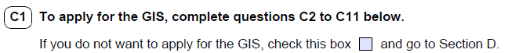
The OAS application form allows you to apply for the Guaranteed Income Supplement (GIS).
Example of the check box in Section C of the OAS and GIS application form.
Do not check the box on the form to opt out of the GIS. Opting out means you will not get extra money from GIS.
Start gathering your application documents early, especially if you were born outside Canada. If you apply on time, you should start getting these benefits the month after you turn 65.
- Tell OW/ODSP about any seniors’ benefits you get right away
Social assistance will probably start sending you letters when you turn 64, reminding you to apply for OAS. You have an obligation to apply and to report to social assistance. This means you should:

OW and ODSP do not automatically know if you or your spouse/partner are receiving seniors’ benefits, even if they told you to apply. You must tell them you or your spouse/partner are getting seniors’ benefits. Most people cannot receive both seniors’ benefits and social assistance at the same time. If you receive both, you may end up owing OW/ODSP money.
- Apply for a fee waiver for the seniors’ drug program before you turn 65
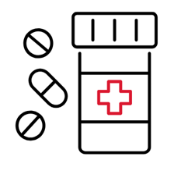
When you turn 65, your drug coverage doesn’t come from OW/ODSP anymore. Seniors with an OHIP card are enrolled automatically in the Ontario Drug Benefit program, which will cover most prescription drug costs. But after the age of 65, you will have to pay a $100 deductible every year and up to $6.11 per prescription unless you request a fee waiver.
Apply for a waiver from the Seniors Co-Payment Program (SCP) up to three months before you turn 65 so you won’t have to pay the $100 deductible. The fastest way to apply is online. Applications are also available at pharmacies or by calling 416-503-4586. The waiver is for low-income seniors. You only have to apply for the fee waiver once, as long as you and your spouse (if any) file your taxes every year.
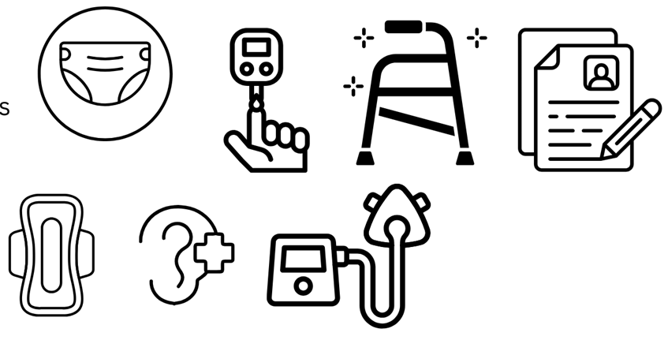
- Use your heath benefits before you turn 65
Social assistance can provide extra money for other health needs not usually covered under seniors’ income benefits such as travel to medical appointments, special diets related to medical conditions, diabetic, surgical and incontinence supplies, mobility device repairs and batteries, and hearing, vision, and dental care.
Use your OW/ODSP health benefits before you turn 65. There may be forms that your doctors must complete to prove your health expenses.
Talk to your social assistance case worker about things you need for your health before you turn 65. You could call or write them and ask about getting “Mandatory Special Necessities” and the “Special Diet Allowance” forms, which require sign-off from your healthcare provider.
Bonus tip – if you have high medical costs:
Before you turn 65, apply for “Extended Health Benefits” from Ontario Works (OW) or the Ontario Disability Support Program (ODSP)
Seniors’ income benefits like OAS and CPP do not include health benefits. You can apply to OW or ODSP before you leave social assistance to keep your health benefits if you have high average health expenses.
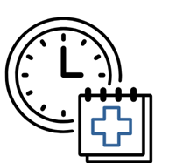
Apply for “Extended Health Benefits” through your local OW or ODSP office. You can look yours up here: http://www.officelocator.mcss.gov.on.ca/.
Collect proof of your health costs, such as a list of prescription drug costs from your pharmacy, the cost of travel to medical appointments, receipts for medical devices or medical supplies like adult diapers, wound care, or diabetes supplies.

Links From This Tipsheet and Other Helpful Resources
Service Canada GIS/OAS application website (includes link for paper application download): https://www.canada.ca/en/services/benefits/publicpensions/old-age-security/apply.html
Find your local ODSP and OW office: http://www.officelocator.mcss.gov.on.ca/
Community legal clinics can help with government benefit problems. Find your local clinic: https://www.legalaid.on.ca/legal-clinics/
Ontario Drug Benefit Seniors Co-Payment Program (SCP) information (including how to apply for the SCP): https://www.ontario.ca/page/seniors-ontario-drug-benefit-deductible-and-prescription-co-payment
Navigating Benefits at Age 65 (Ontario): https://www.realizecanada.org/wp-content/uploads/Navigating-Benefits-at-65-in-Ontario_Realize_FINAL.pdf
Open Policy Ontario – Retiring on a Low Income: https://openpolicyontario.com/retiring-on-a-low-income-3/
Canadian Dental Care Plan: https://www.canada.ca/en/services/benefits/dental/dental-care-plan/apply.html
Steps to Justice – What happens to my ODSP when I turn 65?: https://stepstojustice.ca/questions/income-assistance/what-happens-my-odsp-when-i-turn-65/
Government of Ontario – A guide to programs and services for seniors: https://www.ontario.ca/document/guide-programs-and-services-seniors/health-and-well-being
Diabetes Canada’s Ontario Monitoring for Health Program for diabetic supplies: https://www.diabetes.ca/get-involved/local-programs-events/ontario-monitoring-for-health-program
Free tax clinics: https://www.canada.ca/en/revenue-agency/services/tax/individuals/community-volunteer-income-tax-program/need-a-hand-complete-your-tax-return.html
Government of Canada – Retirement Hub: https://www.canada.ca/en/services/life-events/retirement.html

This tip sheet was prepared by the Income Security Advocacy Centre (ISAC). Information and links are accurate and up-to-date as of April 2026. For more helpful tip sheets, updates, and information about our work, visit www.incomesecurity.org.

